**Queue implementation using Array**

int main() {

int choice;

while (1) {

printf("\n1. Insert element to queue\n");

printf("2. Delete element from queue\n");

printf("3. Display all elements of queue\n");

printf("4. Quit\n");

printf("Enter your choice: ");

scanf("%d", &choice);

switch (choice) {

case 1:

enqueue();

break;

case 2:

dequeue();

break;

case 3:

display();

break;

case 4:

exit(0);

default:

printf("Wrong choice\n");

}

}

return 0;

}

#include <stdio.h>

#include<stdlib.h>

#define MAX 50

int queue[MAX];

int front = -1;

int rear = -1;

void enqueue(){

int x;

if(rear == MAX -1 )

printf("Overflow\n");

else{

if(front == -1)

front = 0;

}

printf("Insert the element in queue: ");

scanf("%d", &x);

rear = rear + 1;

queue[rear] = x;

}

void dequeue (){

if (front == -1 || front > rear)

printf("Underflow\n");

else{

printf("Element deleted is: %d\n",

queue[front]);

front ++;

}

}

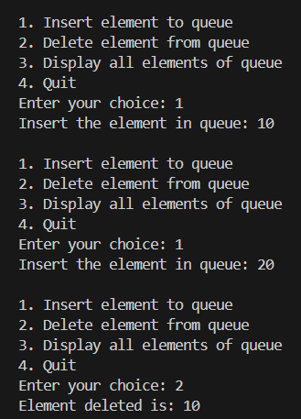

void display(){

if(front == -1)

printf("Empty\n");

else{

printf("Elements: ");

for(int i = front; i<=rear; i++)

printf("%d ", queue[i]);

printf("\n");

}

}

**Queue Implementation using Array**

printf("%d ", temp->data);

temp = temp->next;

}

printf("\n"); } }

int main() {

int choice, x;

while (1) {

printf("\n1. Insert element to queue\n");

printf("2. Delete element from queue\n");

printf("3. Display all elements of queue\n");

printf("4. Quit\n");

printf("Enter your choice: ");

scanf("%d", &choice);

switch (choice) {

case 1:

printf("Insert the element in queue: ");

scanf("%d", &x);

enqueue(x); break;

case 2:

dequeue(); break;

case 3:

display(); break;

case 4:

exit(0);

default:

printf("Wrong choice\n");

} }

return 0;

}

#include <stdio.h>

#include<stdlib.h>

typedef struct node{

int data;

struct node* next;

} Node;

Node* front = NULL;

Node* rear = NULL;

void enqueue(int x){

Node* temp = (Node*)malloc(sizeof(Node));

temp->data = x;

temp->next = NULL;

if(rear == NULL)

front = rear = temp;

else{

rear->next = temp;

rear=temp;

}

}

void dequeue(){

if(front == NULL)

printf("Queue Empty\n");

else{

Node* temp = front;

printf("Deleted Element is: %d\n", front->data);

front = front -> next;

if(front == NULL){

rear == NULL;

}

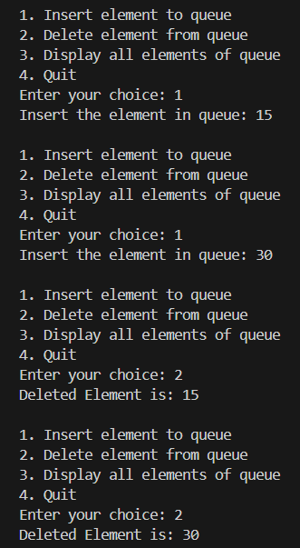

free(temp);

}

}

void display(){

if(front == NULL)

printf("Queue Empty");

else{

printf("Elements: ");

Node* temp = front;

while(temp!=NULL){